This tutorial is going to focus on a specific aspect of objects in uiz: Backgrounds. Backgrounds? No, not the type of backgrounds that fills your room like in the normal game maker, we are talking about “uiz object backgrounds”.

A uiz background is like a base of how the objects should look.

Here are two different objects with the same background: (a stringbox and checkbox):

IMAGE 20:

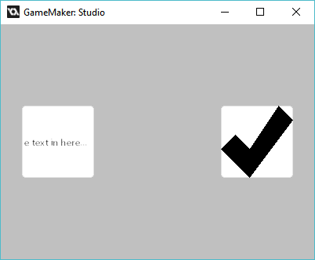

**So I do specify a background?** Well, easy. You just need to know which variables to edit for an object. To find out, open the manual and go to “Object background & stitching”. Here you can find all available background scripts.

IMAGE 21:

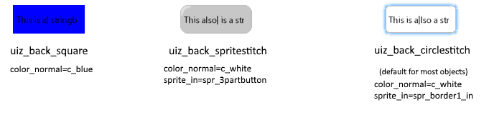

Most often the default texturescript is uiz_back_circlestitch.

To edit the texturescript that is being used simply change the variable “texturescript” for an instance that has a background.

The variable names for the way a background should look is:

* sprite_texturemode
* border_texturemode
* sprite_normal
* color_normal
* margin_normal
* sprite_over
* color_over
* margin_over
* sprite_in
* color_in
* margin_in
* sprite_out
* color_out
* margin_out

Here’s a table showing the what values are used:

|  |  |  |
| --- | --- | --- |
| Mouse not over object | Mouse hovers over object | Mouse clicks object |
| -texturescript  -sprite_normal  -color_normal  -margin_normal  -sprite_texturemode  -border_texturemode | -texturescript  -sprite_over  -color_over  -margin_over  -sprite_texturemode  -border_texturemode | -texturescript  -sprite_in  -color_in  -margin_in  -sprite_texturemode  -border_texturemode |

**Sprite and margins:** There is not one single way that every background scripts implements/handles margins and sprites. Some backgroundscripts will require a sprite with one image, while others would need 12 images or something. How these react to sprite and margins can be found in the manual in the page “Object background & stitching” Just note that some objects also use the margin variables inside their own code. For example, the stringbox will not draw any text outside it’s given margin.

**Spritestitching** is a term, and a way a backgroundscript can work. For example, a button might have seem like one single image, but it is in fact build up out of several sprites.  
IMAGE 22:

  
When these different sprites are being combined into one sprite that is called "stitching" in uiz.

**Texturemode:** Texturemode is another thing you need to understand. It influences the way sprites are stitched together. There are 3 texturemodes:

* uiz_texturemode_fill
* uiz_texturemode_tile
* uiz_texturemode_tilefit
* Here is a picture showing the different texturemodes:

IMAGE 23:

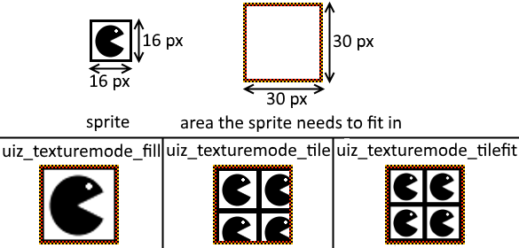

**Values of -1.** A lot of times, when you don’t want to specify some values or just want to use default values, setting some variables to -1 will automatically handle it. This doesn’t work for every single variable, so it’s a good thing to read the manual article about backgrounds.

That concludes stuff for this tutorial. This tutorial didn’t get into every single variable into detail and had way less example codes, so I do hope you understand everything, and are able to make your own backgrounds for uiz objects. (making your own background scripts will be covered in another tutorial)